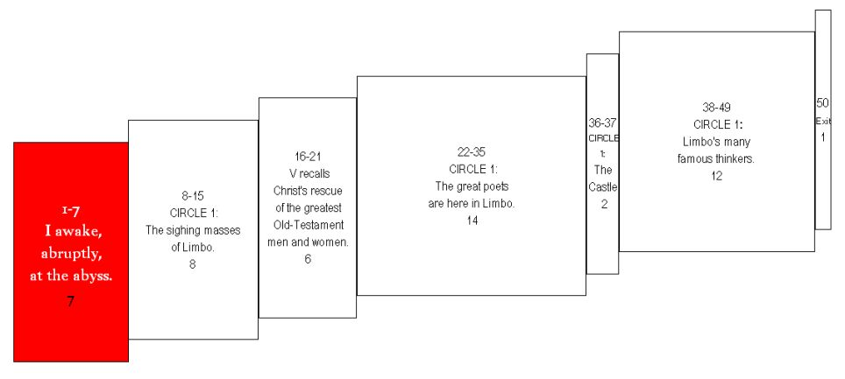
It cracked the deep sleep in my head—
1 h4> Ruppemi l'alto sonno ne la testa [1] | A heavy thunderclap broke the deep sleep in my head,
a heavy thunderclap—and I jerked
2 h4> un greve truono, sì ch'io mi riscossi | so that I started up
awake, like a man dragged from bed,
3 h4> come persona ch'è per forza desta; | like a person who is waked by force,
and put my rested eye to work.
4 h4> e l'occhio riposato intorno mossi, [2] | and, risen erect, I moved my rested eye round about,
I pulled myself up straight. I stared all around.
5 h4> dritto levato, e fiso riguardai | and looked fixedly
I wanted to know where we were.
6 h4> per conoscer lo loco dov' io fossi. | to distinguish the place where I was.

The brink, to tell the truth, is where I found
7 h4> Vero è che 'n su la proda mi trovai [3] | True it is, that I found myself on the brink
myself—of the valley, the sorrowful abyss
8 h4> de la valle d'abisso dolorosa | of the woeful valley of the abyss
collecting the thunder that’s infinite sadness’s sound.
9 h4> che ‘ntrono accoglie d'infiniti guai. | which collects a thunder of infinite wailings.
Darkness. Deepness. Clouds of mist.
10 h4> Oscura e profonda era e nebulosa [4] | It was so dark, deep, and cloudy,
My seeing strained for the bottom, for something defined—
11 h4> tanto che, per ficcar lo viso a fondo, | that, though I fixed my sight on the depth,
there wasn’t anything that I could distinguish.
12 h4> io non vi discernea alcuna cosa. | I did not discern anything there.
“Now we go down there, the world that’s blind,”
13 h4> «Or discendiam qua giù nel cieco mondo», [5] | “Now let us descend here below into the blind world,”
the poet began, in a deathly pallor.
14 h4> cominciò il poeta tutto smorto. | began the Poet all deadly pale,
“I’ll be first and you’ll come behind.”
15 h4> «Io sarò primo, e tu sarai secondo». | “I will be first, and thou shalt be second.”
And I, well aware of his color,
16 h4> E io, che del color mi fui accorto, [6] | And I, who had observed his color,
said, “How can I, with you fearful?
17 h4> dissi: «Come verrò, se tu paventi | said, “How shall I come, if thou fearest,
You’re the one who turns my doubts to valor.”
18 h4> che suoli al mio dubbiare esser conforto?». | who art wont to be the comfort to my doubting?”
And he to me: “It’s the agony of the people
19 h4> Ed elli a me: «L'angoscia de le genti [7] | And he to me: “The anguish of the folk
down there. The white that paints my face is . . .
20 h4> che son qua giù, nel viso mi dipigne | who are here below paints on my face
pity. You think fright’s responsible.
21 h4> quella pietà che tu per tema senti. | that pity which thou takest for fear.

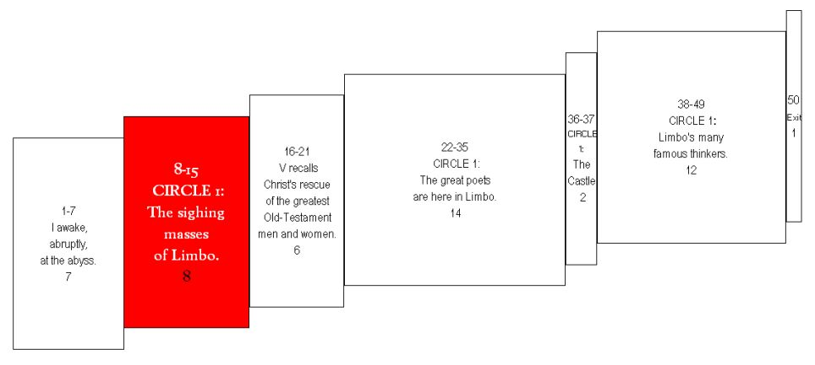
We’ve got to go. The long way insists.”
22 h4> Andiam, ché la via lunga ne sospigne». [8] | Let us go on, for the long way urges us.”
With that he put himself, and then had me, enter
23 h4> Così si mise e così mi fé intrare | Thus he placed himself, and thus he made me enter
the first circle binding the abyss.
24 h4> nel primo cerchio che l'abisso cigne. | into the first circle that girds the abyss.
Which, as I listen, seems where
25 h4> Quivi, secondo che per ascoltare, [9] | Here, as one listened,
it is not sobs but sighs
26 h4> non avea pianto mai che di sospiri | there was no lamentation but that of sighs
that shake forever’s air,
27 h4> che l'aura etterna facevan tremare; | which made the eternal air to tremble;

as the pain that won’t physically agonize
28 h4> ciò avvenia di duol sanza martìri, [10] | this came of the woe without torments
afflicts the many multitudes, each vast,
29 h4> ch'avean le turbe, ch'eran molte e grandi, | felt by the crowds, which were many and great,
of of women, of men, of babies.
30 h4> d'infanti e di femmine e di viri. | of infants and of women and of men.
b
The good teacher to me: “Not going to ask
31 h4> Lo buon maestro a me: «Tu non dimandi [11] | The good Master to me: “Thou dost not ask
whom you see now—about these spirits?
32 h4> che spiriti son questi che tu vedi ? | what spirits are these that thou seest.
I’d have you know, before you walk past,
33 h4> Or vo' che sappi, innanzi che più andi, | Now I would have thee know, before thou goest farther,
that they did not sin. And if they had merit,
34 h4> ch'ei non peccaro; e s'elli hanno mercedi, [12] | that these did not sin; and though they have merits
it weren’t enough. They did not have baptism,
35 h4> non basta, perché non ebber battesmo, | it suffices not, because they did not have baptism,
the gateway to faith, as you believe in it.
36 h4> ch'è porta de la fede che tu credi; | which is part of the faith that thou believest;
If they were prior to the Christian ism,
37 h4> e s’e’ furon dinanzi al cristianesmo, [13] | and if they were before Christianity,
they didn’t worship God as one ought to.
38 h4> non adorar debitamente a Dio: | they did not duly worship God:
As these are, am I. I’m like them.
39 h4> e di questi cotai son io medesmo. | and of such as these am I myself.

Because of such flaws, and no other taboo,
40 h4> Per tai difetti, non per altro rio, [14] | For such defects, and not for other guilt,
we’re helpless, with one lone affront to be withstood:
41 h4> semo perduti, e sol di tanto offesi | are we lost, and only so far harmed
live hopeless—always to want to, never to do.”
42 h4> che sanza speme vivemo in disio». | that without hope we live in desire.”
Great pain gripped my heart. I understood.
43 h4> Gran duol mi prese al cor quando lo 'ntesi, [15] | Great woe seized me at my heart when I heard him,
People of stature
44 h4> però che gente di molto valore | because I knew that people of much worth
were suspended in this limbo for good.
45 h4> conobbi che 'n quel limbo eran sospesi. | were suspended in that limbo.

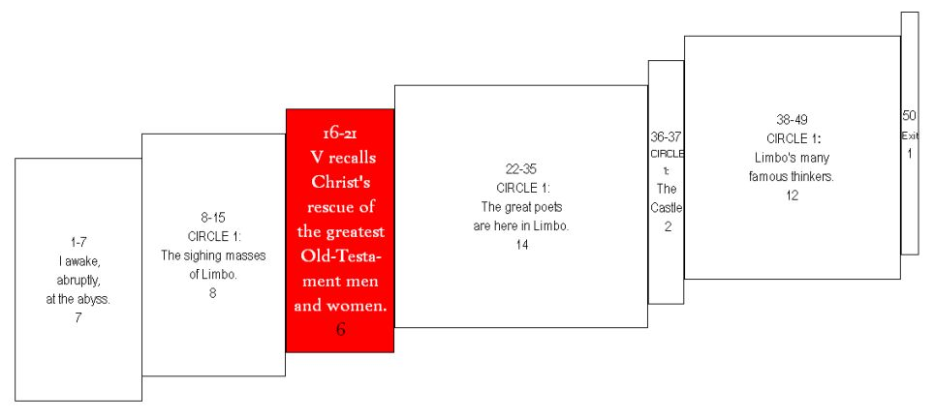
“Tell me, my teacher, tell me, dear sir,”
46 h4> «Dimmi, maestro mio, dimmi, segnore», [16] | “Tell me, my Master, tell me, Lord,”
I began, out of a wish to hear it
47 h4> comincia' io per voler esser certo | I began, with wish to be assured
validated—the faith that conquers all error—
48 h4> di quella fede che vince ogne errore: | of that faith which vanquishes every error,
“Did anyone ever get out, through personal merit—
49 h4> «uscicci mai alcuno, o per suo merto [17] | “did ever anyone who afterwords was blessed go forth
or another’s—and then go on to salvation?”
50 h4> o per altrui, che poi fosse beato?». | from here, either by his own or by another’s merit?”
Easily reading my words’ secret,
51 h4> E quei che 'ntese il mio parlar coverto, | And he, who understood my covert speech,

he replied, “I was new to this situation,
52 h4> rispuose: «Io era nuovo in questo stato, [18] | answered: “I was new in this state
when I saw one come here absolutely potent,
53 h4> quando ci vidi venire un possente, | when I saw a Mighty One come hither
crowned with the sign of domination.
54 h4> con segno di vittoria coronato. | crowned with sign of victory.
He took a soul away, the shade of our first parent,
55 h4> Trasseci l'ombra del primo parente, [19] | He drew out hence the shade of the first parent,
and that of his son Abel, and of Noah,
56 h4> d'Abèl suo figlio e quella di Noè, | of Abel his son, and that of Noah,
of lawgiving Moses the obedient;
57 h4> di Moïsè legista e ubidente; | of Moses the law-giver and obedient,
Abraham the patriarch, and David the ruler,
58 h4> Abraàm patrïarca e Davìd re, [20] | Abraham the patriarch, and David the King,
Israel, together with his father and his offspring
59 h4> Israèl con lo padre e co' suoi nati | Israel with his father and with his offspring,
and his Rachel—think of all he did for her—
60 h4> e con Rachele, per cui tanto fé, | and with Rachel, for whom he did so much,
and many more ascended into his blessing.
61 h4> e altri molti, e feceli beati. [21] | and many others; and He made them blessed:
And I would have you know that before those,
62 h4> E vo' che sappi che, dinanzi ad essi, | and I would have thee know that before these,
there’d never, of any human spirit, been a rescuing.”
63 h4> spiriti umani non eran salvati». | human spirits were not saved.”
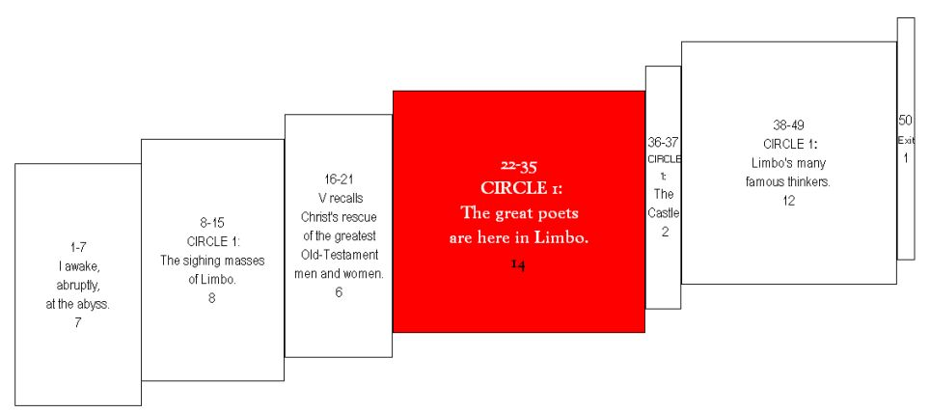
We don’t stop for him to say this, but stroll
64 h4> Non lasciavam l'andar perch' ei dicessi, [22] | We ceased not going on because he spoke,
straight on the whole time, through a forest,
65 h4> ma passavam la selva tuttavia, | but all the while were passing through the wood,
a forest, I should say, of jam-packed souls.
66 h4> la selva, dico, di spiriti spessi. | the wood, I mean, of crowded spirits;
We’d added little to our journey’s progress
67 h4> Non era lunga ancor la nostra via [23] | nor yet had our way been long
since this side of my sleep, when I saw a fire
68 h4> di qua dal sonno, quand' io vidi un foco | from the place of my slumber, when I saw a fire,
beating back the dome of the darkness.
69 h4> ch'emisperio di tenebre vincia. | which overcame a hemisphere of darkness.
Although we were still a little far,
70 h4> Di lungi n'eravamo ancora un poco, [24] | We were still a little distant from it,
we weren’t so distant I couldn’t see, in part,
71 h4> ma non sì ch'io non discernessi in parte | yet not so far but that I could in part discern
that this was a place of people to admire.
72 h4> ch'orrevol gente possedea quel loco. | that honorable folk possessed that place.

“O you who honor knowledge and art,
73 h4> «O tu ch'onori scïenzïa e arte, [25] | “O thou who honorest both science and art,
who are these people being shown such honor?
74 h4> questi chi son c'hanno cotanta onranza, | who are these, who have such honor
What keeps the others’ condition and theirs apart?”
75 h4> che dal modo de li altri li diparte?». | that it separates them from the manner of the others?”
And that one to me: “The honorable wonder
76 h4> E quelli a me: «L'onrata nominanza [26] | And he to me: “The honorable renown
over them of your lives up above is music
77 h4> che di lor suona sù ne la tua vita, | of them which sounds above in thy life
earning them heaven’s grace, which moves them onward.”
78 h4> grazïa acquista in ciel che sì li avanza». | wins grace in heaven which thus advances them.”
A voice I heard then came quick:
79 h4> Intanto voce fu per me udita: [27] | At this a voice was heard by me:
“Show honor to the highest poet!
80 h4> «Onorate l'altissimo poeta; | “Honor the loftiest Poet!
His shade returns! He who departed is back.”
81 h4> l'ombra sua torna, ch'era dipartita». | his shade returns which had departed.”
And when the voice paused, and was quiet,
82 h4> Poi che la voce fu restata e queta, [28] | When the voice had stopped and was quiet,
I saw that four large shades were coming our way,
83 h4> vidi quattro grand' ombre a noi venire: | I saw four great shades coming to us;
each of their faces without gloom or joy in it.
84 h4> sembianz' avevan né trista né lieta. | they had a semblance neither sad nor glad.
Then the good teacher began to say,
85 h4> Lo buon maestro cominciò a dire: [29] | The good Master began to say:
“Look at the one holding the sword,
86 h4> «Mira colui con quella spada in mano, | “Look at him with that sword in hand
going first, as if the three were in his sway.
87 h4> che vien dinanzi ai tre sì come sire: | who comes before the three, even as lord;
He is Homer, poetry’s sovereign lord.
88 h4> quelli è Omero poeta sovrano; [30] | he is Homer, the sovereign poet;
Next comes Horace, whose poems bite.
89 h4> l'altro è Orazio satiro che vene; | next who comes is Horace, the satirist;
Ovid is third, and Lucan, lastly, fourth.
90 h4> Ovidio è 'l terzo, e l'ultimo Lucano. | Ovid is the third, and the last is Lucan.
Since I and these individuals unite
91 h4> Però che ciascun meco si convene [31] | Since each shares with me
the title you heard one voice alone outpour,
92 h4> nel nome che sonò la voce sola, | the name which the single voice sounded,
they do me honor, and in so doing do right.”
93 h4> fannomi onore, e di ciò fanno bene». | they do me honor, and in that do well.”
And so I saw, in assembly, the glorious corps
94 h4> Così vid' i' adunar la bella scola [32] | Thus I saw assembled the fair school
of that lord of the highest song,
95 h4> di quel segnor de l'altissimo canto | of that Lord of the loftiest song
who’s as far above the rest as eagle can soar.
96 h4> che sovra li altri com' aquila vola. | who soars above the others like an eagle.

After they’d talked among themselves, not long,
97 h4> Da ch'ebber ragionato insieme alquanto, [33] | After they had discoursed somewhat together,
they turned and gestured. Salute seemed what they meant.
98 h4> volsersi a me con salutevol cenno, | they turned to me with sign of salutation;
My master smiled along—
99 h4> e 'l mio maestro sorrise di tanto; | and my Master smiled thereat.
There was greater honor yet for me to experience:
100 h4> e più d’onore ancora assai mi fenno, [34] | And far more honor yet they did me,
They made me one of them—their fellow maker!
101 h4> ch'e' sì mi fecer de la loro schiera, | for they made me of their band,
and a sixth of such uncommon sense.
102 h4> sì ch'io fui sesto tra cotanto senno. | so that I was the sixth amid so much wisdom.
Then we all walked as far as the flare,
103 h4> Così andammo infino a la lumera, [35] | Thus we went on as far as the light,
speaking of things as excellent now not to tell
104 h4> parlando cose che 'l tacere è bello, | speaking things concerning which silence is becoming,
as it was to say them when I was there.
105 h4> sì com' era 'l parlar colà dov' era. | even as was speech there where I was.

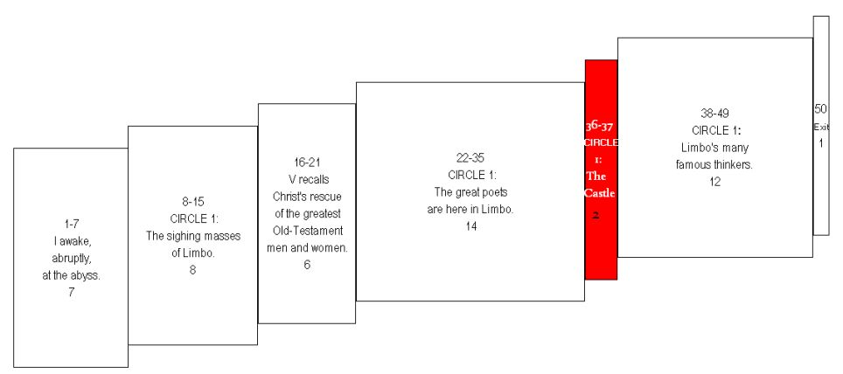
We came to the foot of a noble castle
106 h4> Venimmo al piè d'un nobile castello, [36] | We came to the foot of a noble castle,
that seven surrounding high walls enclose,
107 h4> sette volte cerchiato d’alte mura, | seven times circled by high walls,
with a lovely little circle of a stream for outer obstacle.
108 h4> difeso intorno d'un bel fiumicello. | defended round about by a fair streamlet.
As though this were hard earth, across we go.
109 h4> Questo passammo come terra dura; [37] | This we passed as if on hard ground;
I entered seven gates with this wise company.
110 h4> per sette porte intrai con questi savi: | through seven gates I entered with these sages;
Then we came . . . upon a fresh green meadow
111 h4> giugnemmo in prato di fresca verdura. | we came to a meadow of fresh verdure.

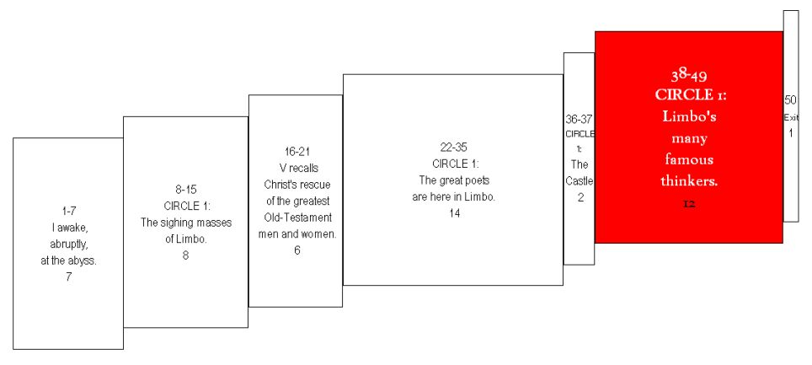
of people with the slow eyes of dignity
112 h4> Genti v'eran con occhi tardi e gravi, [38] | People were there with slow and grave eyes,
and the powerful face of accomplishment.
113 h4> di grande autorità ne' lor sembianti: | of great authority in their looks;
They seldom spoke. When they did it was gently.
114 h4> parlavan rado, con voci soavi. | they spoke seldom, and with soft voices.
There we withdrew a little, and went
115 h4> Traemmoci così da l’un de’ canti, [39] | Thereon we withdrew ourselves upon one side,
where it was so high, bright, and spacious
116 h4> in loco aperto, luminoso e alto, | into an open, luminous, and high place,
that we could distinguish everyone present.
117 h4> sì che veder si potien tutti quanti. | so that they all could be seen.
And there, along the green varnish,
118 h4> Colà diritto, sovra 'l verde smalto, [40] | There before me up on the green enamel
the magnificent spirits were shown to me.
119 h4> mi fuor mostrati li spiriti magni, | were shown to me the great spirits,
And that I saw them—I!—is bliss.
120 h4> che del vedere in me stesso m'essalto. | whom for having seen I inwardly exalt myself.

I saw Electra, with many of her tree,
121 h4> I' vidi Eletra con molti compagni, [41] | I saw Electra with many companions,
among whom I could recognize Hector and Aeneas,
122 h4> tra ' quai conobbi Ettòr ed Enea, | among whom I recognized Hector and Aeneas,
and Caesar, in armor, with a falcon’s eye’s intensity.
123 h4> Cesare armato con li occhi grifagni. | Cæsar in armor, with his gerfalcon eyes;
I saw Camilla’s shade, and Penthesilea’s,
124 h4> Vidi Cammilla e la Pantasilea; [42] | I saw Camilla and Penthesilea,
and elsewhere Latinus the king
125 h4> da l'altra parte vidi 'l re Latio | on the other side I saw the King Latinus,
at the side of his daughter Lavinia, at rest.
126 h4> che con Lavina sua figlia sedea. | who was sitting with Lavinia his daughter.
I saw the Brutus who drove out Tarquin;
127 h4> Vidi quel Bruto che cacciò Tarquino, [43] | I saw that Brutus that drove out Tarquin;
Lucretia, Julia, Marcia, Cornelia;
128 h4> Lucrezia, Iulia, Marzïa e Corniglia; | Lucretia, Julia, Marcia, and Cornelia;
and alone, off by himself, Saladin.
129 h4> e solo, in parte, vidi 'l Saladino. | and alone, apart, I saw the Saladin.
When I’d lifted the lashes a little higher,
130 h4> Poi ch'innalzai un poco più le ciglia, [44] | When I raised my brows a little more,
I saw the teacher of the ones with the knowledge
131 h4> vidi 'l maestro di color che sanno | I saw the Master of those who know,
sitting among his philosophical familia.
132 h4> seder tra filosofica famiglia. | seated amid the philosophic family:

All gaze at him. All pay homage.
133 h4> Tutti lo miran, tutti onor li fanno: [45] | all regard him, all do him honor.
This is where I saw Socrates and Plato,
134 h4> quivi vid' ïo Socrate e Platone, | Here I saw Socrates and Plato,
a little in front of the others’ vantage.
135 h4> che 'nnanzi a li altri più presso li stanno; | who in front of the others stand nearest to him;
Democritus—“Earth’s as it is by dice throw”—
136 h4> Democrito che 'l mondo a caso pone, [46] | Democritus, who ascribes the world to chance;
Diogenes, Anaxagoras, Thales,
137 h4> Dïogenès, Anassagora e Tale, | Diogenes, Anaxagoras, and Thales,
Empedocles, Heraclitus, and Zeno.
138 h4> Empedoclès, Eraclito e Zenone; | Empedocles, Heraclitus, and Zeno;
I see the good collector of the qualities—
139 h4> e vidi il buono accoglitor del quale, [47] | and I saw the good collector of the qualities,
Dioscorides, that is—and Orpheus. I see
140 h4> Dïascoride dico; e vidi Orfeo, | Dioscorides, I mean; and I saw Orpheus,
Cicero, Linus, Seneca, famouse for morality,
141 h4> Tulïo e Lino e Seneca morale; | Tully, and Linus, and moral Seneca,
geometry’s Euclid, Ptolemy,
142 h4> Euclide geomètra e Tolomeo, [48] | Euclid the geometer, and Ptolemy,
Hippocrates, Avicenna, Galen,
143 h4> Ipocràte, Avicenna e Galïeno, | Hippocrates, Avicenna, and Galen,
Averroës, who made the great commentary.
144 h4> Averoìs, che 'l gran comento feo. | and Averrhoës, who made the great comment.
I cannot sketch, much less portray, each one.
145 h4> Io non posso ritrar di tutti a pieno, [49] | I cannot report of all in full,
The long theme’s on my trail. It’s my pursuer.
146 h4> però che sì mi caccia il lungo tema, | because the long theme so drives me
So the telling will often fall short of what was done.
147 h4> che molte volte al fatto il dir vien meno. | that many times the speech comes short of the fact.
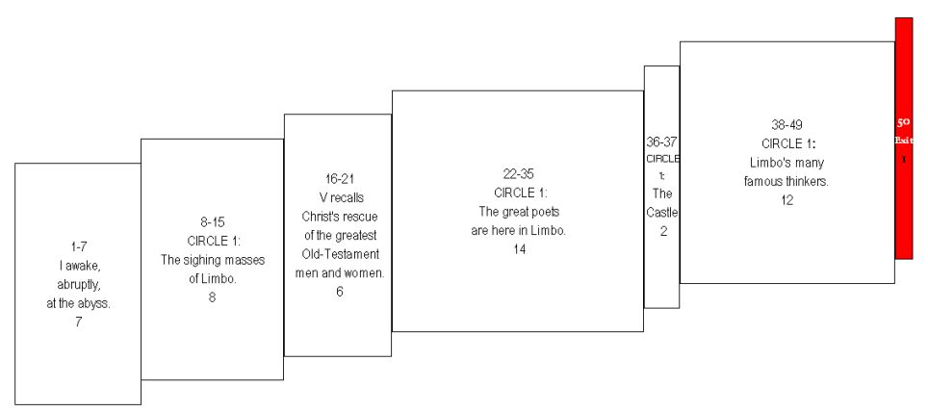
The band of six thins to a pair.
148 h4> La sesta compagnia in due si scema: [50] | The company of six is reduced to two.
By a different way, the wise leader’s,
149 h4> per altra via mi mena il savio duca, | By another way the wise guide leads me
led out of the still and through the shaking air,
150 h4> fuor de la queta, ne l'aura che trema. | out from the quiet into the air that trembles,
I come to a place where nothing that makes light is.
151 h4> E vegno in parte ove non è che luca. | and I come into a region where is nothing that can give light.

