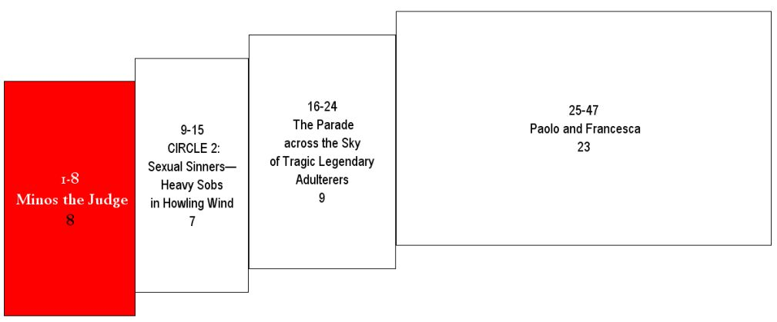
So I’d descended, from Circle One going
1 h5> Così discesi del cerchio primaio [1] | Thus I descended from the first circle
down into the second. This smaller circle’s
2 h5> giù nel secondo, che men loco cinghia | down into the second, which girdles less space,
greater grief is so penetrating everyone’s groaning.
3 h5> e tanto più dolor, che punge a guaio. | and so much more woe that it goads to wailing.
Right there, monstrously: Minos! He snarls.
4 h5> Stavvi Minòs orribilmente, e ringhia: [2] | There stands Minos horribly, and snarls:
He calculates the guilt walking in,
5 h5> essamina le colpe ne l’intrata ; | He examines the transgressions at the entrance;
judges, passes sentence with his coils.
6 h5> giudica e manda secondo ch'avvinghia. | he judges, and he sends according as he entwines himself.
I mean that when the soul born condemned
7 h5> Dico che quando l'anima mal nata [3] | I mean that when the ill born soul
comes before him, it confesses all,
8 h5> li vien dinanzi, tutta si confessa; | comes there before him, it confesses itself wholly,
and then that connoisseur of sin
9 h5> e quel conoscitor de le peccata | and that discerner of the sins
determines its appropriate infernal locale.
10 h5> vede qual loco d'inferno è da essa; [4] | sees what place of Hell is for it;
He binds himself in his tail, in as many rings
11 h5> cignesi con la coda tante volte | he girds himself with his tail so many times
as the level he wants it sent to—down to that circle.
12 h5> quantunque gradi vuol che giù sia messa. | as the grades he wills that it be sent down.
Before him, always, many are gathering.
13 h5> Sempre dinanzi a lui ne stanno molte: [5] | Always many of them stand before him;
They go, one by one, each in turn, to the decision.
14 h5> vanno a vicenda ciascuna al giudizio, | they go, in turn, each to the judgment;
They tell, they hear, then down they’re sent spiraling.
15 h5> dicono e odono e poi son giù volte. | they speak and hear, and then are whirled below.
“You—the arrival at sorrow’s inn,”
16 h5> «O tu che vieni al doloroso ospizio», [6] | “O thou that comest to the woeful inn,”
said Minos to me when he sees us,
17 h5> disse Minòs a me quando mi vide, | said Minos to me, when he saw me,
leaving the duties of his great position.
18 h5> lasciando l'atto di cotanto offizio, | leaving the act of so great an office,
“Be careful coming in, and whom it is you trust.
19 h5> «guarda com' entri e di cui tu ti fide; [7] | “beware how thou enterest, and to whom thou trustest thyself;
Don’t be taken in by the wide-open door.”
20 h5> non t'inganni l'ampiezza de l'intrare!». | let not the amplitude of the entrance deceive thee.”
The leader—my leader—to him: “You too shout at us?
21 h5> E 'l duca mio a lui: «Perché pur gride? | And my Leader to him: “Wherefore dost thou too cry out?

Don’t get in the way of what he was born for.
22 h5> Non impedir lo suo fatale andare: [8] | Hinder not his fated going;
This is the will of where what can be done
23 h5> vuolsi così colà dove si puote | thus it is willed there where is power
is whatever is willed. Not a word more.”
24 h5> ciò che si vuole, e più non dimandare». | for that which is willed; and ask no more.”

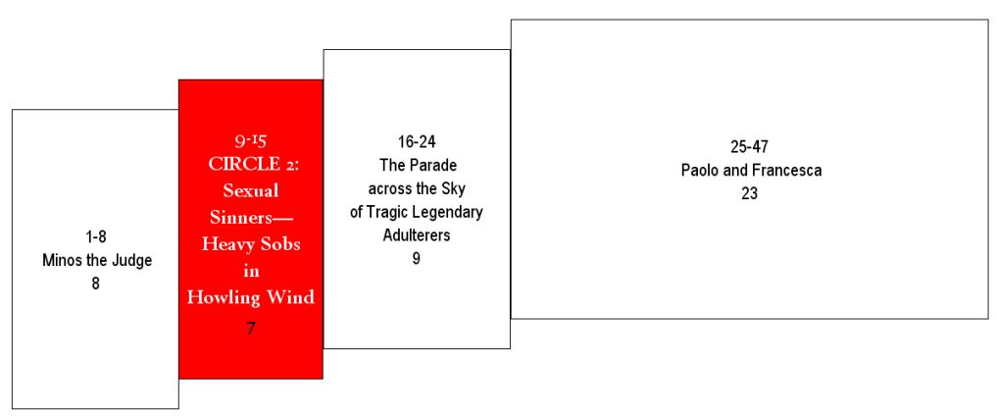
Now notes of grief have begun
25 h5> Or incomincian le dolenti note [9] | Now the notes of woe begin
to make me feel them. My route
26 h5> a farmisi sentire; or son venuto | to make themselves heard by me; now I am come
has sent me against much sobbing’s percussion.
27 h5> là dove molto pianto mi percuote. | where much wailing smites me.
I’d come to a place where light is mute,
28 h5> Io venni in loco d’ogne luce muto, [10] | I had come into a place mute of all light,
that bellows like the ocean in a tempest,
29 h5> che mugghia come fa mar per tempesta, | that bellows as the sea does in a tempest,
if battled by winds challenging its route.
30 h5> se da contrari venti è combattuto. | if it be combated by contrary winds.
This infernal typhoon, which does not rest,
31 h5> La bufera infernal, che mai non resta, [11] | The infernal hurricane which never rests
sweeps the spirits enclosed in its onslaught on,
32 h5> mena li spirti con la sua rapina; | carries along the spirits with its rapine;
tumbling them, drumming them, their plague and pest.
33 h5> voltando e percotendo li molesta. | whirling and smiting it molests them.
When they encounter the ruin head on,
34 h5> Quando giungon davanti a la ruina, [12] | When they arrive before its rush,
that’s where the howling is, the sobs, the lament,
35 h5> quivi le strida, il compianto, il lamento; | here are the shrieks, the complaint, and the lamentation;
the spitting out of curses at divine dominion.
36 h5> bestemmian quivi la virtù divina. | here they blaspheme the divine power.
I realized this was the torment
37 h5> Intesi ch'a così fatto tormento [13] | I understood that to such torment
of sinners damned for sexual wrongdoing,
38 h5> enno dannati i peccator carnali, | are condemned the carnal sinners,
whose clear thought had submitted to carnal intent.
39 h5> che la ragion sommettono al talento. | who subject the reason to the appetite.
In the way that when it’s cold the starling’s wing
40 h5> E come li stornei ne portan l'ali [14] | And as their wings bear along the starlings
hoists the entire assembly as a wide, packed mass,
41 h5> nel freddo tempo, a schiera larga e piena, | in the cold season in a large and full troop,
so with the sinful spirits and the panting
42 h5> così quel fiato li spiriti mali | so did that blast the evil spirits;
that heaves them up, and down, and that way, and this.
43 h5> di qua, di là, di giù, di sù li mena; [15] | hither, thither, down, up it carries him;
There is, forever, not a comforting hope to be had—
44 h5> nulla speranza li conforta mai, | no hope ever comforts them,
not for pause, not for pain to ever be less.
45 h5> non che di posa, ma di minor pena. | neither of repose, nor of less pain.

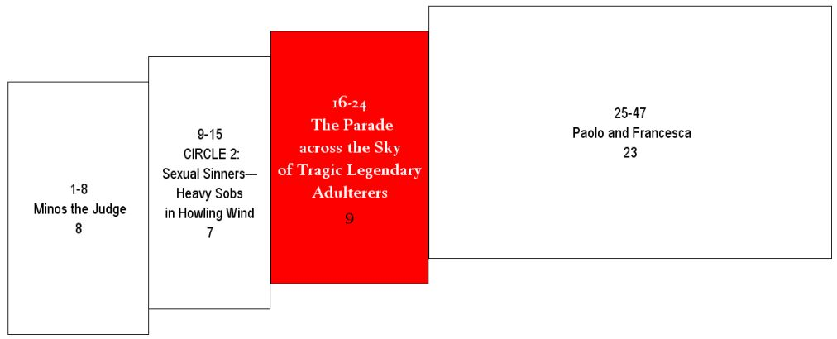
Like the cranes who go chanting their ballad,
46 h5> E come i gru van cantando lor lai, [16] | And as the cranes go singing their lays,
who sketch the air with themselves and make a long line—
47 h5> faccendo in aere di sé lunga riga, | making in air a long line of themselves,
I saw a line like theirs coming, sounding even more sad:
48 h5> così vid’ io venir, traendo guai, | so I saw come, uttering wails,
ghosts aboard their own distress (as defined),
49 h5> ombre portate da la detta briga; [17] | shades borne along by the aforesaid strife.
so that I said, “Teacher, name for me some
50 h5> per ch'i' dissi: «Maestro, chi son quelle | Wherefore I said: “Master, who are these
of the people this black air grinds.”
51 h5> genti che l'aura nera sì gastiga?». | folk whom the black air so castigates?”
“Most important, the first among
52 h5> «La prima di color di cui novelle [18] | “The first of those of whom thou wishest
those you’ll want to know,” he said—
53 h5> tu vuo' saper», mi disse quelli allotta, | to have knowledge,” said he to me then,
“is she, empress once over many a tongue,
54 h5> «fu imperadrice di molte favelle. | “was empress of many tongues.
and to the voluptuous vice so abandoned
55 h5> A vizio di lussuria fu sì rotta, [19] | She was so abandoned to the vice of luxury
that she legalized every need, and freed
56 h5> che libito fé licito in sua legge, | that lust she made licit in her law,
herself from blame for the life she’d conducted.
57 h5> per tòrre il biasmo in che era condotta. | to take away the blame into which she had been brought.
She is Semiramis, of whom we read
58 h5> Ell' è Semiramìs, di cui si legge [20] | She is Semiramis, of whom it is read
that she succeeded Ninus—she was his wife—
59 h5> che succedette a Nino e fu sua sposa: | that she succeeded Ninus and had been his wife;
and ruled the land where the Sultan now leads.
60 h5> tenne la terra che 'l Soldan corregge. | she held the land which the Sultan rules.
The other, so very in love, took her own life,
61 h5> L'altra è colei che s'ancise amorosa, [21] | That other is she who, for love, slew herself,
and broke faith with the ashes of Sichaeus.
62 h5> e ruppe fede al cener di Sicheo; | and broke faith to the ashes of Sichaeus;
After them, Cleopatra, so voluptuous all her life.
63 h5> poi è Cleopatràs lussurïosa. | next is Cleopatra, the luxurious.
See? Helen, on whose account many a heinous
64 h5> Elena vedi, per cui tanto reo [22] | See Helen, for whom so long
year rolled by—and look: the great Achilles,
65 h5> tempo si volse, e vedi 'l grande Achille, | a time of ill revolved; and see the great Achilles,
who went into battle with love . . . to his finish.
66 h5> che con amore al fine combatteo. | who fought to the end with love.

See? Paris, Tristan—.” And a thousand or more of these
67 h5> Vedi Parìs, Tristano»; e più di mille [23] | See Paris, Tristan—” and more than a thousand
his finger pointed out—he named each on sight—
68 h5> ombre mostrommi e nominommi a dito, | shades whom love had parted from our life he showed me,
the departed from our lives, asked by Love to leave.
69 h5> ch'amor di nostra vita dipartille. | and pointing to them, named to me.
After I’d heard my great tutor recite
70 h5> Poscia ch'io ebbi 'l mio dottore udito [24] | After I had heard my Teacher
the roll of ladies of old and men of chivalry,
71 h5> nomar le donne antiche e ' cavalieri, | name the dames of eld and the cavaliers,
pity overtook me, and no way out felt right.
72 h5> pietà mi giunse, e fui quasi smarrito. | pity overcame me, and I was well nigh bewildered.

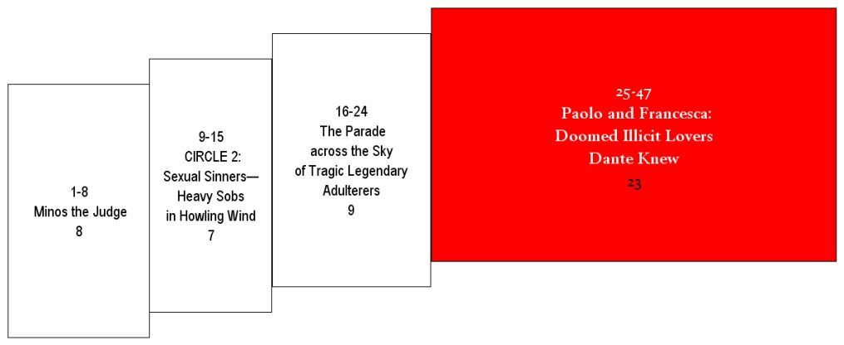
“Poet,” I began, “willingly
73 h5> I' cominciai: «Poeta, volontieri [25] | I began: “Poet, willingly
would I speak with the two who go so together,
74 h5> parlerei a quei due che 'nsieme vanno, | would I speak with those two that go together,
seemingly in this wind weightlessly.”
75 h5> e paion sì al vento esser leggeri». | and seem to be so light upon the wind.”
He to me: “Do this. When they’re
76 h5> Ed elli a me: «Vedrai quando saranno [26] | And he to me: “Thou shalt see when
closer to us, beg their attention—say
77 h5> più presso a noi; e tu allor li priega | they are nearer to us, and do thou then pray them
you do so by the love driving them—they’ll be here.”
78 h5> per quello amor che i mena, ed ei verranno». | by that love which leads them, and they will come.”
The instant the wind has folded them our way,
79 h5> Sì tosto come il vento a noi li piega, [27] | Soon as the wind sways them towards us,
I forced my voice: “Souls! Whom all this must exhaust,
80 h5> mossi la voce: «O anime affannate, | I lifted my voice: “O wearied souls,
come talk, if Another doesn’t say Don’t stay.”
81 h5> venite a noi parlar, s'altri nol niega!». | come to speak with us, if Another deny it not.”
The way doves called for by desire, aloft
82 h5> Quali colombe dal disio chiamate [28] | As doves, called by desire,
on motionless wings, reach the sweet nest through air
83 h5> con l’ali alzate e ferme al dolce nido | with wings open and steady, come through the air
that only by their will they’re borne across,
84 h5> vegnon per l’aere, dal voler portate; | borne by their will to their sweet nest,
they exit the crew that Dido’s in, this pair.
85 h5> cotali uscir de la schiera ov' è Dido, [29] | these issued from the troop where Dido is,
To us, through air so evilhearted, they sped,
86 h5> a noi venendo per l'aere maligno, | coming to us through the malign air,
my cry was that strong, my feelings that bare.
87 h5> sì forte fu l'affettüoso grido. | so strong was the compassionate cry.
“O creature, by your gracious kind heart led
88 h5> «O animal grazïoso e benigno [30] | “O living creature, gracious and benign,
through this air of ebony-purple to converse
89 h5> che visitando vai per l'aere perso | that goest through the black air visiting us
with we who dyed the world blood-of-the-mulberry red—
90 h5> noi che tignemmo il mondo di sanguigno, | who stained the world blood-red,
if He were our friend, the King of the universe,
91 h5> se fosse amico il re de l'universo, [31] | if the King of the universe were a friend
we’d pray to Him for your peace:
92 h5> noi pregheremmo lui de la tua pace, | we would pray Him for thy peace,
you pity our plight, you see it’s perverse.
93 h5> poi c'hai pietà del nostro mal perverso. | since thou hast pity on our perverse ill.

Whatever to hear or say would please,
94 h5> Di quel che udire e che parlar vi piace, [32] | Of what it pleases thee to hear, and what to speak,
that is what we’ll hear and say with you,
95 h5> noi udiremo e parleremo a voi, | we will hear and we will speak to you,
while the wind—there—gets as quiet for us as a breeze.
96 h5> mentre che ‘l vento, come fa, ci tace. | while the wind, as now, is hushed for us.
The city I was born in has a view
97 h5> Siede la terra dove nata fui [33] | The city where I was born sits
of the seashore where the Po descends
98 h5> su la marina dove 'l Po discende | upon the seashore, where the Po,
for peace, as his followers likewise do.
99 h5> per aver pace co' seguaci sui. | with his followers, descends to have peace.
Love, hunting the noble heart, is lightning, and apprehends,
100 h5> Amor, ch'al cor gentil ratto s'apprende, [34] | Love, which quickly lays hold on gentle heart,
and got him, with the beautiful body
101 h5> prese costui de la bella persona | seized this one for the fair person
ripped away from me—how it was still offends.
102 h5> che mi fu tolta; e 'l modo ancor m'offende. | that was taken from me, and the mode still hurts me.
Love, when one’s loved, excuses from love—nobody,
103 h5> Amor, ch'a nullo amato amar perdona, [35] | Love, which absolves no loved one from loving,
and got me, with pleasure in him so strong I’m left,
104 h5> mi prese del costui piacer sì forte, | seized me for the pleasing of him so strongly that,
as you see, with it. It hasn’t abandoned me.
105 h5> che, come vedi, ancor non m'abbandona. | as thou seest, it does not even now abandon me.

Love conducted us to one death.
106 h5> Amor condusse noi ad una morte. [36] | Love brought us to one death.
Cain’s ring is expecting our life’s snuffer.”
107 h5> Caina attende chi a vita ci spense». | Cain awaits him who quenched our life.”
From them to us these words were swept.
108 h5> Queste parole da lor ci fuor porte. | These words were borne to us from them.
When I’d heard what these souls had had to suffer,
109 h5> Quand' io intesi quell' anime offense, [37] | Soon as I had heard those injured souls
I bowed my head, and was so long keeping it low
110 h5> china' il viso, e tanto il tenni basso, | I bowed my face, and held it down so long
“Your thoughts?” the poet had to mutter.
111 h5> fin che 'l poeta mi disse: «Che pense?». | until the Poet said to me: “What art thou thinking?”
When I could reply, I began, “Oh!
112 h5> Quando rispuosi, cominciai: «Oh lasso, [38] | When I replied, I began: “Alas!
How many sweet thoughts, how much yearning,
113 h5> quanti dolci pensier, quanto disio | how many sweet thoughts, how great desire,
has driven them into sorrow’s control!”
114 h5> menò costoro al doloroso passo!». | led these unto the woeful pass.”
Then I faced them again, turning,
115 h5> Poi mi rivolsi a loro e parla' io, [39] | Then I turned me again to them, and spoke,
and began: “Francesca, your . . . tortures
116 h5> e cominciai: «Francesca, i tuoi martìri | and began: “Francesca, thy torments
have me in tears, awe, and mourning.
117 h5> a lagrimar mi fanno tristo e pio. | make me sad and piteous to weeping.

But tell me: during the sweet sighs’ hours,
118 h5> Ma dimmi: al tempo d'i dolci sospiri, [40] | But tell me, at the time of the sweet sighs,
what did, and how did love let go
119 h5> a che e come concedette amore | by what and how did love concede
to permit recognition of uncertain desires?”
120 h5> che conosceste i dubbiosi disiri?». | to thee to know thy dubious desires?”
She to me: “No greater sorrow
121 h5> E quella a me: «Nessun maggior dolore [41] | And she to me: “There is no greater woe
than remembering a happy year
122 h5> che ricordarsi del tempo felice | than the remembering in misery the happy time,
from depths . . . as your professor must know.
123 h5> ne la miseria; e ciò sa 'l tuo dottore. | and that thy Teacher knows.
But knowledge of the first root of our love would appear
124 h5> Ma s'a conoscer la prima radice [42] | But if thou hast so great a desire
to be a thing your sympathies might treasure.
125 h5> del nostro amor tu hai cotanto affetto, | to know the first root of our love,
So I’ll tell—I’ll be somebody talking shedding a tear.
126 h5> dirò come colui che piange e dice. | I will do like one who weeps and tells.
We were reading one day, for pleasure,
127 h5> Noi leggiavamo un giorno per diletto [43] | We were reading one day, for delight,
about Lancelot—how love was closing in.
128 h5> di Lancialotto come amor lo strinse; | of Lancelot, how love constrained him.
We were alone, suspecting nothing whatsoever.
129 h5> soli eravamo e sanza alcun sospetto. | We were alone and without any suspicion.

Rousing our eyes again and again,
130 h5> Per più fïate li occhi ci sospinse [44] | Many times that reading urged our eyes,
reading kept draining our faces pale,
131 h5> quella lettura, e scolorocci il viso; | and took the color from our faces,
but one point only did us in.
132 h5> ma solo un punto fu quel che ci vinse. | but only one point was it that overcame us.
When we read his heart’s desire—her smile—
133 h5> Quando leggemmo il disïato riso [45] | When we read of the longed-for smile
being kissed, and by such a lover,
134 h5> esser basciato da cotanto amante, | being kissed by such a lover,
this one—never to be, from me, separable—
135 h5> questi, che mai da me non fia diviso, | this one, who never shall be divided from me,
kissed my mouth, trembling all over.
136 h5> la bocca mi basciò tutto tremante. [46] | kissed my mouth all trembling.
Our Gallehault that book was—so was its scribe,
137 h5> Galeotto fu 'l libro e chi lo scrisse: | Gallehaut was the book, and he who wrote it.
and that day we read in it no farther.”
138 h5> quel giorno più non vi leggemmo avante». | That day we read no farther in it.”
While the one spirit testified,
139 h5> Mentre che l'uno spirto questo disse, [47] | While the one spirit said this,
the other one sobbed, till pity forced farewell.
140 h5> l'altro piangëa; sì che di pietade | the other was so weeping that through pity
I fainted as though I’d just died,
141 h5> io venni men così com' io morisse. | I swooned as if I had been dying,
and like a corpse falling over, fell.
142 h5> E caddi come corpo morto cade. | and fell as a dead body falls.

